User Job Aid: Create New non-VA User Record (Faculty Version)
Purpose
The purpose of this job aid is to guide users through the step-by-step process of creating the Create New User tool in the VA TMS. In this job aid you will learn how to:
- Create New User Record 9 Steps
- Complete Required Training 6 Steps

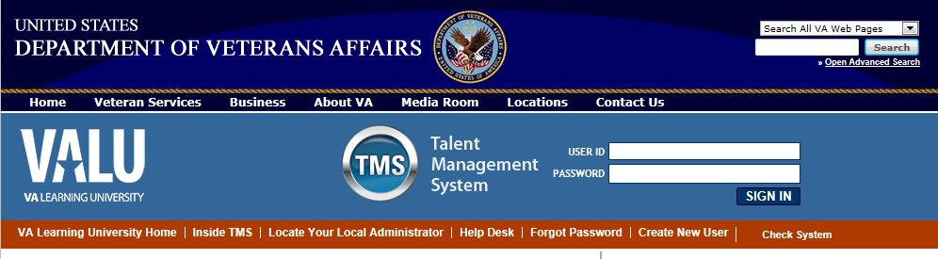
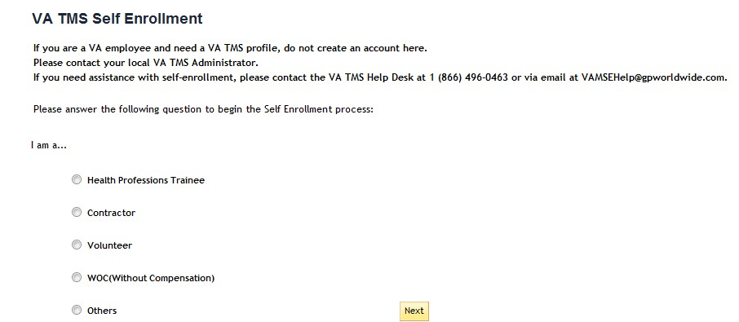
Task A. Go to www.tms.va.gov to Create New User Record

Step 1

From the
Login

page,
in the
brown

navigation bar
click
the
Create
New User
link.

Step 2

In the
VA TMS Self
Enrollment

page
,
select
the
appropriate employment
type
.

Step 3

Click

Next
.

NOTE:
All Faculty will select
WOC (Without

compensation
”
.

1

1

2

2

3

3

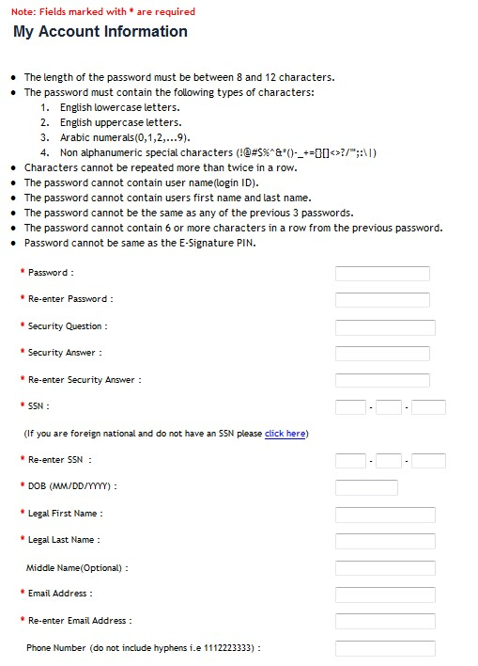
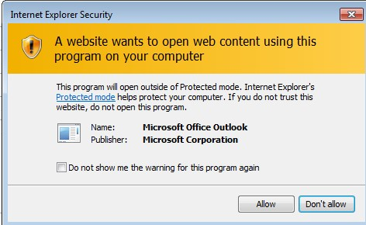
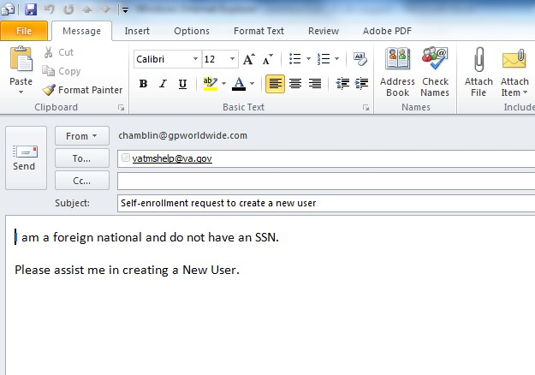
Step 4 In My Account Information section, fill in all required fields as noted by the red asterisk, taking care to type accurately when entering your Social Security Number, e-mail address, and legal name; proceed to Step 5.

4
c

4
a

4
b

4

4a Step 4a
If you are a foreign national, click the click here link.

4b Step 4b
If there is a security pop-up click Allow.

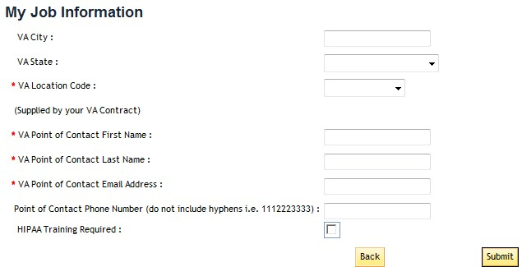
Nivia.Crawford@va.gov 404-321-6111 ext 4814

Step 5

In
My Job Information

section,

fill in all
required
fields as noted by the red
asterisk
, entering the data
provided by your VA point
of contact where
appropriate
.

VA City: Decatur

VA State: GA

VA Location Code: ATG

VA

POC
:
Nivia Crawford

Email:

5

5

6

7

6
Step 6
Click the box for the Health Insurance Portability and Accountability Act (HIPPA).
Step 7
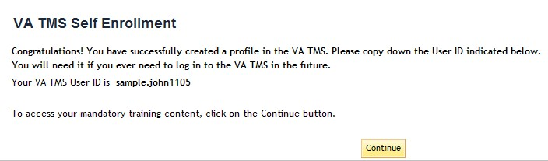
Click Submit.
Step
8

From the

congratulations

page,
note your

VA TMS
USER ID for future use.

Step
9

C
lick
Continue
.

9

8

8

7

Do not exit out of the VA TMS site until you have completed the mandatory training content.
9

9
a

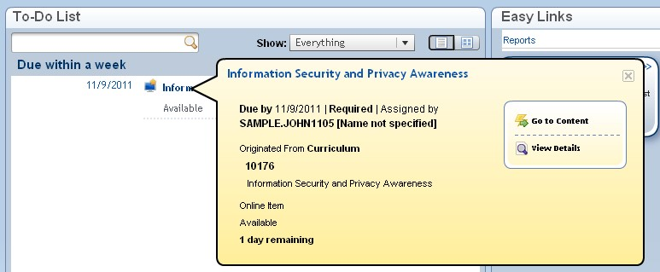
Task B. Complete Required Training

Step 1

From the
Home

page,
hover
over

item
in your To Do List

to display the pop
-
up menu
.

Step 2

Click Go to Content.

Step 3

1

1

2

2

3

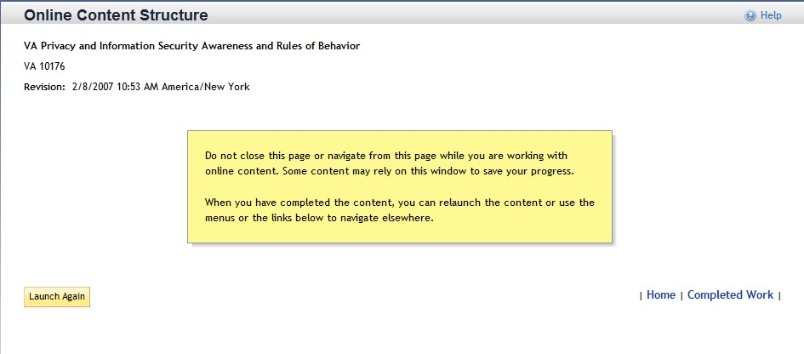
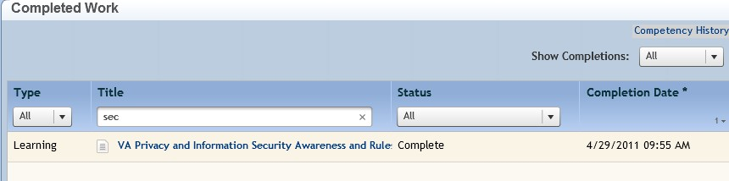
Complete training per instructions.

Step 4

On the Online Content
Structure page, click the
Complete
d

Work link.

Step 5

From the Complete
d

Work
page, hover over
the title of
the
completed

training to
display the pop
-
up menu.

4

4

5

5

6 Step 6
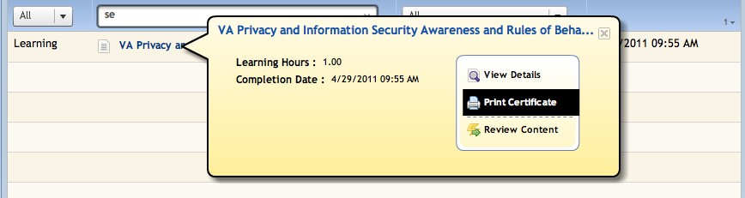
Click Print Certificate.

6

^{c} Step 4c In the email pop-up add any additional information to assist the Admin like your name and contact information and click Send.

