One USG - Payroll
You are required to always record the hours that you work for us. From now on, if you do not submit timecards for the month, you will not get paid. The amount you are paid is not based on these hours.
Instructions for inputting your hours:
- The following is a link to the site or you may use the Human Resources link on the Kennesaw.edu website. I recommend that you bookmark this site. http://oneusgconnect.usg.edu/
- This should be what you see :

- Click on the link OneUSG Connect (orange arrow).
- When the page opens, you will see a list of college and university logos for the University System of Georgia. Select the icon for Kennesaw State University.
- Login in using your KSU login and your KSU password (the same one you use for your KSU email).

- The following screen will appear, showing Employee Self Service. If you have not already, verify your information in the personal details tab.
- Select the Time and Absence tab (red arrow) to input your hours.
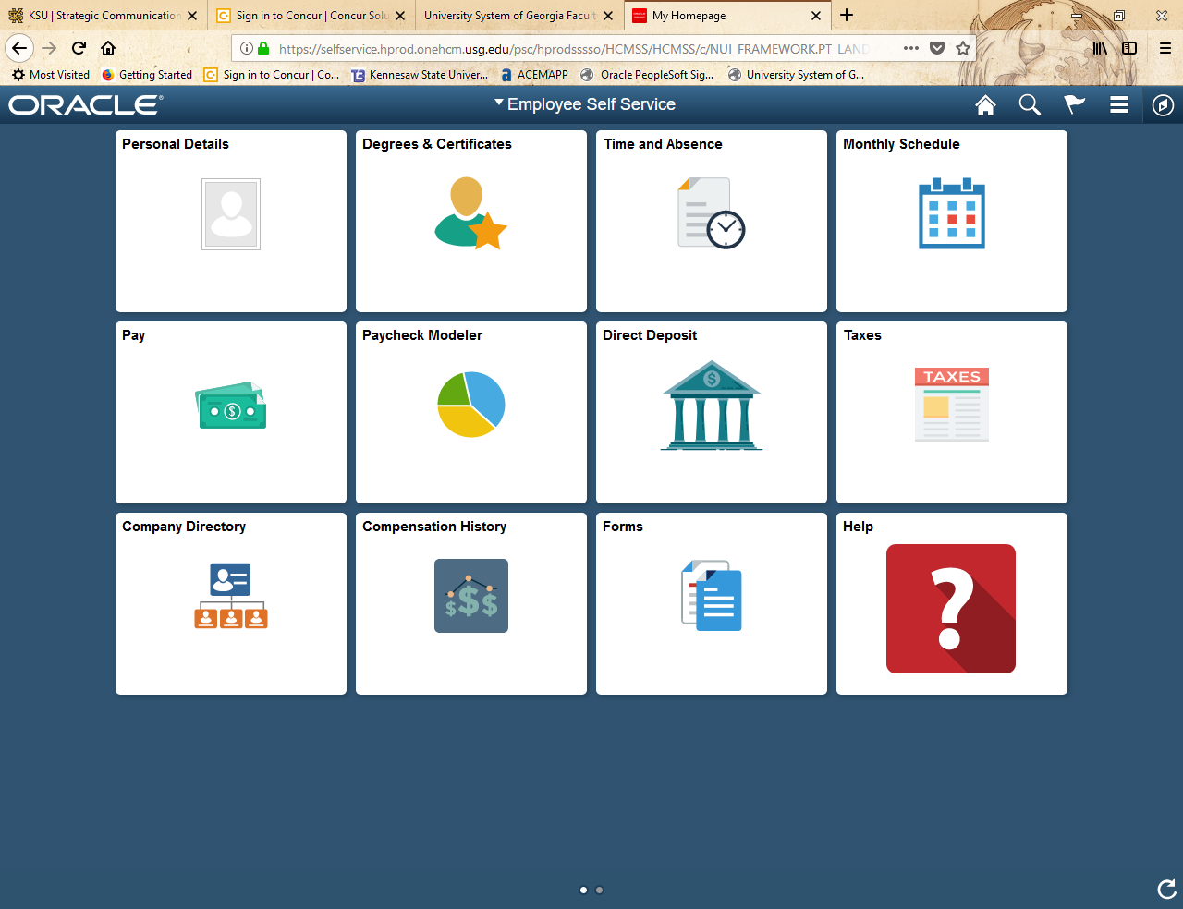
- On the next page, click on the “Weekly Timesheet” link.
- Here is an example timesheet:
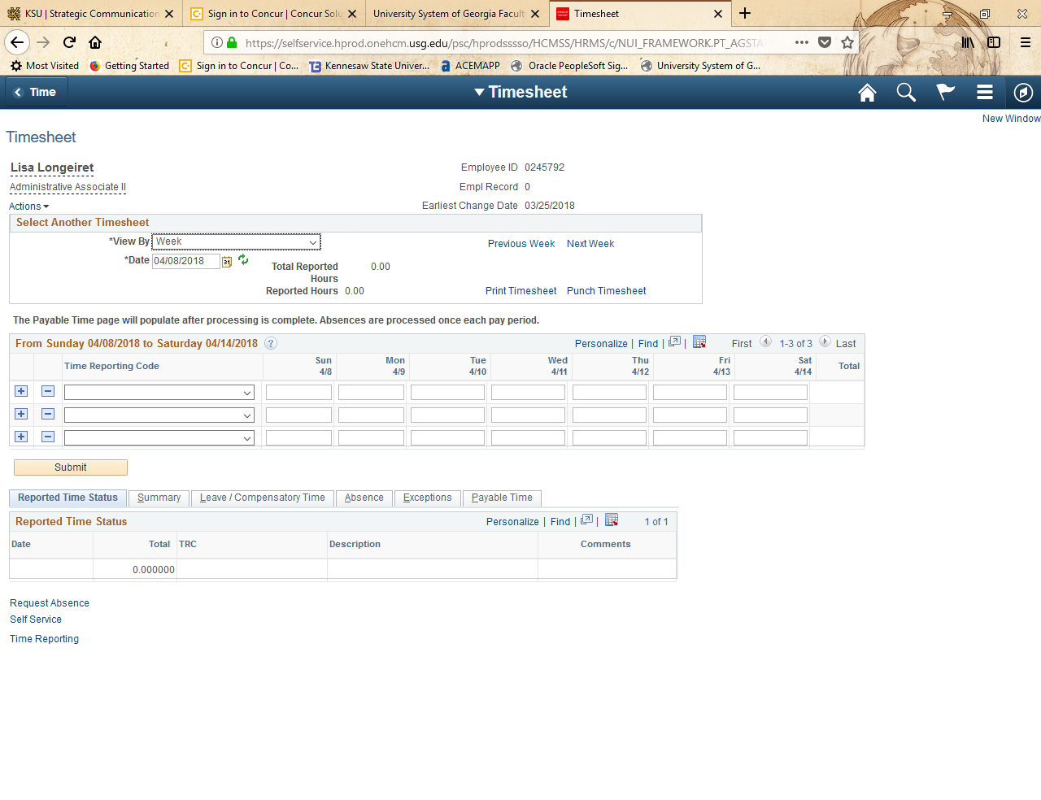
Steps for Filling in a Timesheet:
- Check the date and make sure it is the correct week (orange arrow). If you need to input hours for a different week, click on the “Previous Week” or “Next Week” clickable links (green arrow) to find the correct workweek.
- Find the “Time Reporting Code” box (blue arrow), click on the drop down menu, and select the “00ACA ACA Tracking” line. Enter in the hours that you worked for us for that week.
- Click the “Submit” button to approve your hours.
- You will need to complete steps 1-3 for every week that you work for us.

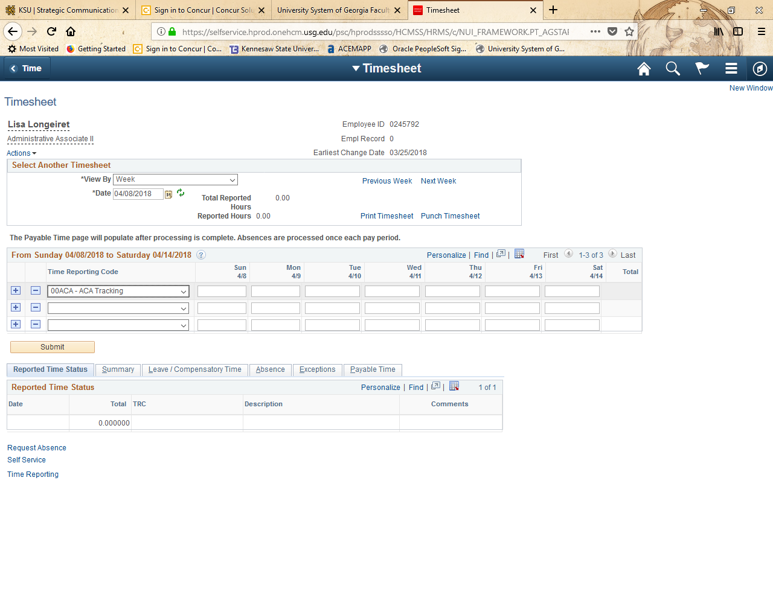
Hopefully, these instructions are helpful, if they are not please let me know and I’ll rewrite them based on your help.
I cannot see your timecards only Dr. Eaves, the Director of the School of Nursing, can see your hours.

