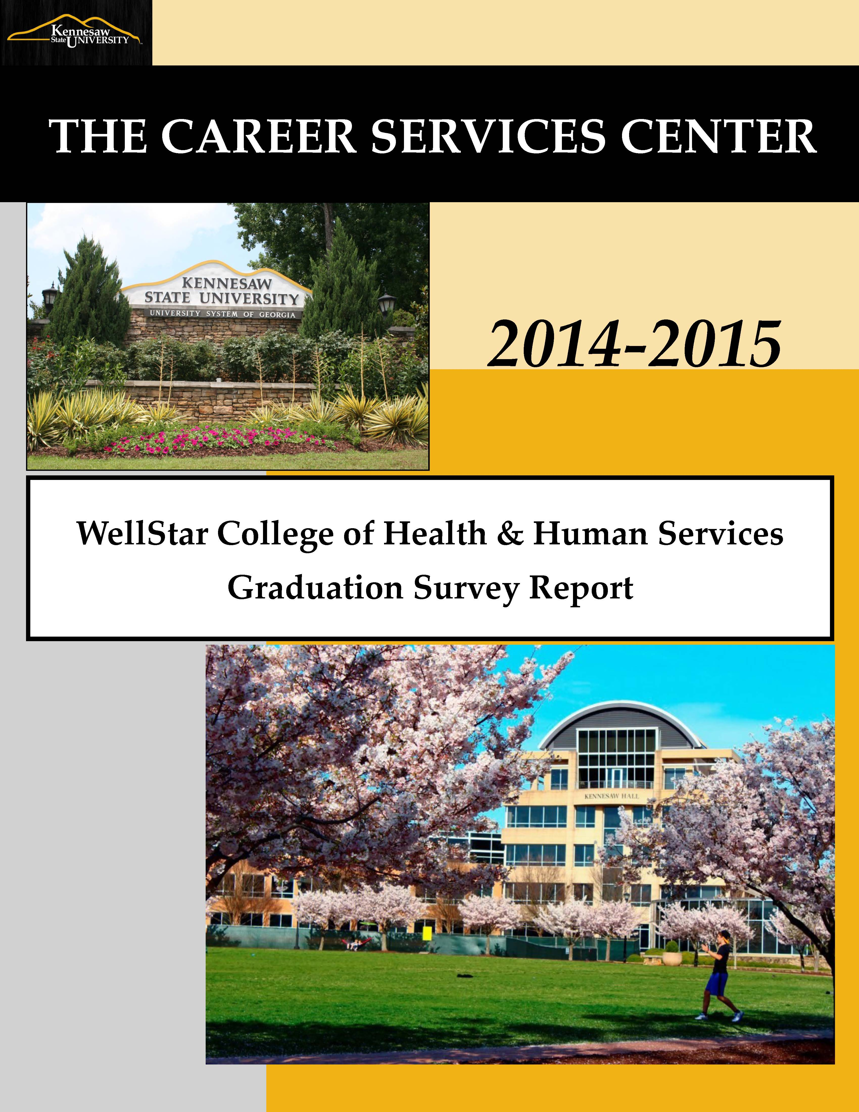
Table of Contents

Introduction / Message from Associate Director …………..………….…………………………………………….. 3

Executive Summary

KSU General Post-Graduation Summary ……………………………………………………………………………. 4

WellStar College of Health & Human Services Results ……………………………………………………….….. 5 ……………………………………………………………………………….. 3

WellStar School of Nursing ……………………………………………………………………………………………. 7

Department of Social Work & Human Services ………………………….………………………………………… 9

Department of Health Promotion & Physical Education …………………………………………………………. 11

Department of Exercise Science & Sport Management …………………………………………………………… 12

Qualitative Data ………………………………………………………………………………….……………………… 15

Introduction

Dear Kennesaw State University Faculty, Staff & Administration:

Each semester, the KSU Career Services Center assesses the post-graduation career status of our recent graduates at each graduation ceremony. The purpose of the survey is to provide the KSU community with a glimpse of the career paths of our students at the time of their graduation. We survey each graduating class (Summer, Fall & Spring graduates) and collect information regarding employment status, graduate school attendance, and experiential education participation.

The college reports are separated by departments and majors for ease of reading. This year we are also including majors from the Marietta campus. If there was a major offered at both campuses, the major report is being divided into the major report at the Kennesaw campus and the major report at the Marietta campus.

We hope this information will encourage the KSU community to continue to support the Career Services Center’s efforts, as well as assist in providing evidence for learning outcomes as designated by the various accrediting bodies. While this data is not a comprehensive First Destination report, it is a snapshot of the graduating class at the time of graduation.

Thank you for taking the time to review the attached. Please feel free to contact me with any questions or comments.

Sincerely,

Lori Trahan, PhD
Associate Director
Career Services Center
Kennesaw State University
470-578-6555
ltrahan@kennesaw.edu

Executive Summary of Findings

- At KSU, “success” means that our students are able to follow any path they may choose, whether that next step is employment, pursuit of further education, or any other goal they may define for themselves. According to this definition, 75.8% of the 2014-2015 survey respondents are successful.

- Common reasons students reported “Other” include: Gap Year, Moving to another state/country, and Starting Own Business.

- CHHS majors reported a 52.1% “Employed” rate at graduation.

- CHHS majors continue to report a high rate of participation in Experiential Education programs (87.2% for 2014-2015)

Within CHHS (excluding graduate programs):

- Nursing majors reported the highest “Employed” and “Employed in Field of Choice” rates at graduation.

- Exercise and Health Science majors reported the highest “Attending a Graduate Program” rate at graduation.

General Results Summary – Results based on survey respondents
KSU Career Services Post-Graduation Survey (Summer 14, Fall 14, & Spring 15)
During the 2014-2015 academic year (Summer 14, Fall 14, & Spring 15 semesters), KSU (both campuses) graduated 5422 students total (including graduate degrees if applicable). 3,750 students completed the Post-Graduation Survey.

Completion Rate: 3750 / 4468 = 69.1%

EMPLOYMENT STATUS:
- Employed = 58.6% (5.6% increase in the number of students reporting they were employed at graduation)
- Respondents reporting a job within their field of choice – 42.5% (21.4% increase in the number of students reporting they were employed in their field of choice at graduation)
- Respondents reporting other employment – 16.2%
- Unemployed = 24.2% (2% decrease in the number of students reporting they were unemployed at graduation)
- Not Seeking Employment = 3.5%
- Attending a Graduate Program = 10.3% (31% decrease in the number of students reporting they will be attending or applying to a graduate program)
  - Respondents reporting that they have been admitted to a graduate program – 3.9%
  - Respondents reporting that they will be applying to a graduate program – 6.4%
- Other = 3.3%

EXPERIENTIAL EDUCATION PARTICIPATION (practical work experience):
- Across all KSU majors = 58.3% *This is an 11.8% decrease in the number of students reporting they participated in Experiential Education.
College of Health & Human Services
General Results Summary – Results based on survey respondents
KSU Career Services Post-Graduation Survey (Summer 14, Fall 14, & Spring 15)
During the 2014-2015 academic year, CHHS graduated 587 students (including graduate students).
461 students completed the Post-Graduation Survey.

Completion Rate: 432 / 650 = 73.4%

EMPLOYMENT STATUS:
- Employed = 52.1% (10.9% increase in the number of CHHS students reporting employment at graduation)
- Respondents reporting a job within their field of choice – 38.4%
- Respondents reporting other employment – 13.7%
- Unemployed = 28.2%
- Not Seeking Employment = 4.2%
- Attending a Graduate Program = 11.8%
  - Respondents reporting that they have been admitted to a graduate program – 3.2%
  - Respondents reporting that they will be applying to a graduate program – 8.6%
- Other = 3.7%

EXPERIENTIAL EDUCATION PARTICIPATION (practical work experience):
- Across all CHHS majors = 87.2% (3.1% decrease in the number of CHHS students reporting they participated in Experiential Education)

WellStar School of Nursing
NURSING (BSN) - Completion Rate: 121 / 210 = 57.6%
Employment status:
- Employed = 55.3%
- Respondents reporting a job within their field of choice – 52.9% (36.3% increase over 2013-2014)
- Respondents reporting other employment – 2.5%
- Unemployed = 38.8%
- Not Seeking Employment = 3.3%
- Attending a Graduate Program = 0.8%
  - Respondents reporting that they have been admitted to a graduate program – 0.8%
  - Respondents reporting that they will be applying to a graduate program – 0%
- Other = 1.7%

*Employed = Employed in field of choice & NOT in field of choice
*Graduate School = Accepted into a program & planning on applying to a program

Experiential Education Participation (practical work experience):
- BSN majors (117/121) = 96.7%

MASTER OF NURSING (MSN) - Completion Rate: 26 / 34 = 76.5%
Employment status:
- Employed = 76.9% (a 53.8% increase over 2013-2014)
- Respondents reporting a job within their field of choice – 42.3%
- Respondents reporting other employment – 34.6%
- Unemployed = 23.1%
- Not Seeking Employment = 0%
- Attending a Graduate Program = 0%
  - Respondents reporting that they have been admitted to a graduate program – 0%
  - Respondents reporting that they will be applying to a graduate program – 0%
- Other = 0%

*Employed = Employed in field of choice & NOT in field of choice
*Graduate School = Accepted into a program & planning on applying to a program

Experiential Education Participation (practical work experience):
- MSN majors (22/24) = 92% (2% increase over AY12)

DOCTORATE OF NURSING SCIENCE (DNS) - Completion Rate: 1 / 1 = 100%
Employment status:
- Employed = 100%
- Respondents reporting a job within their field of choice – 100%
- Respondents reporting other employment – 0%
- Unemployed = 0%
- Not Seeking Employment = 0%
- Attending a Graduate Program = 0%
  - Respondents reporting that they have been admitted to a graduate program – 0%
  - Respondents reporting that they will be applying to a graduate program – 0%
- Other = 0%

Experiential Education Participation (practical work experience):
- DNS majors (0/1) = 0%

Department of Social Work & Human Services
HUMAN SERVICES - Completion Rate: 77 / 92 = 83.7%
Employment status:
- Employed = 50.6% (22.5% increase from 2013-2014)
- Respondents reporting a job within their field of choice – 27.2%
- Respondents reporting other employment – 23.4%
- Unemployed = 24.7%
- Not Seeking Employment = 3.9%
- Attending a Graduate Program = 18.2%
  - Respondents reporting that they have been admitted to a graduate program – 5.2%
  - Respondents reporting that they will be applying to a graduate program –13%
- Other = 2.6%

*Employed = Employed in field of choice & NOT in field of choice
*Graduate School = Accepted into a program & planning on applying to a program

Experiential Education Participation (practical work experience):
- HS majors (71/75) = 95% (4% decrease from AY12)

MASTER OF SOCIAL WORK (MSW) - Completion Rate: 42 / 48 = 87.5%
Employment status:
- Employed = 59.5% (50.3% increase over 2013-2014)
- Respondents reporting a job within their field of choice – 52.4%
- Respondents reporting other employment – 7.1%
- Unemployed = 33.3%
- Not Seeking Employment = 4.8%
- Attending a Graduate Program = 0%
  - Respondents reporting that they have been admitted to a graduate program – 0%
  - Respondents reporting that they will be applying to a graduate program – 0%
- Other = 2.3%

*Employed = Employed in field of choice & NOT in field of choice
*Graduate School = Accepted into a program & planning on applying to a program

Experiential Education Participation (practical work experience):
- MSW majors (42/42) = 100%

Department of Health Promotion & Physical Education
HEALTH & PHYSICAL EDUCATION (HPE) - Completion Rate: 16 / 16 = 100%
Employment status:
- Employed = 43.8% (5.2% decrease from 2013-2014)
- Respondents reporting a job within their field of choice – 43.8%
- Respondents reporting other employment – 0%
- Unemployed = 43.8%
- Not Seeking Employment = 0%
- Attending a Graduate Program = 12.5%
  - Respondents reporting that they have been admitted to a graduate program – 12.5%
  - Respondents reporting that they will be applying to a graduate program – 0%
- Other = 0%

*Employed = Employed in field of choice & NOT in field of choice
*Graduate School = Accepted into a program & planning on applying to a program

Experiential Education Participation (practical work experience):
- HPE majors (16/16) = 100%

Department of Exercise Science & Sport Management
EXERCISE & HEALTH SCIENCE - Completion Rate: 85 / 118 = 72%
Employment status:
- Employed = 37.6% (23.1% decrease over 2013-2014)
- Respondents reporting a job within their field of choice – 18.8%
- Respondents reporting other employment – 18.8%
- Unemployed = 18.1%
- Not Seeking Employment = 4.7%
- Attending a Graduate Program = 34.1%
  - Respondents reporting that they have been admitted to a graduate program – 7.1%
  - Respondents reporting that they will be applying to a graduate program – 27.1%
- Other = 5.9%

*Employed = Employed in field of choice & NOT in field of choice
*Graduate School = Accepted into a program & planning on applying to a program

Experiential Education Participation (practical work experience):
- EHS majors (41/85) = 48.2% (30.4% decrease over 2013-2014)

MASTER OF APPLIED EXERCISE SCIENCE - Completion Rate: 4 / 4 = 100%
Employment status:
- Employed = 25% (58.3% decrease from 2012)
- Respondents reporting a job within their field of choice – 25%
- Respondents reporting other employment – 0%
- Unemployed = 50%
- Not Seeking Employment = 0%
- Attending a Graduate Program = 25%
  - Respondents reporting that they have been admitted to a graduate program – 0%
  - Respondents reporting that they will be applying to a graduate program –25%
- Other = 0%

*Employed = Employed in field of choice & NOT in field of choice
*Graduate School = Accepted into a program & planning on applying to a program

Experiential Education Participation (practical work experience):
- MSAES majors (2/4) = 50%

SPORT MANAGEMENT - Completion Rate: 60 / 64 = 93.8%
Employment status:
- Employed = 55% (10.9% decrease over 2013-2014)
- Respondents reporting a job within their field of choice – 38.3%
- Respondents reporting other employment – 16.7%
- Unemployed = 20%
- Not Seeking Employment = 8.3%
- Attending a Graduate Program = 6.7%
  - Respondents reporting that they have been admitted to a graduate program – 1.7%
  - Respondents reporting that they will be applying to a graduate program – 10%
- Other = 0%

*Employed = Employed in field of choice & NOT in field of choice
*Graduate School = Accepted into a program & planning on applying to a program

Experiential Education Participation (practical work experience):
- SM majors (60/60) = 100%

QUALITATIVE DATA

Employer Information

Career Services asks students who are employed in the field of choice for the name of the company for whom they will be working. Below are the names of the employers. If an employer name has a number behind their name, that particular employer was mentioned by that number of students as having hired them. Employer names without a number were listed by one (1) student only. Majors not listed had no students reporting data in this category.

Exercise Science
Central Gymnastics Academy
Formwell Persona Fitness
Kennesaw State University
Northpoint Fitness
Orange Theory Fitness
PT Solutions
Rapid Sports Performance
The Blitz
Union General Hospital
US Army (2)
US Marine Corps
WellStar Health Systems (2)

Health and Physical Education
Barrow County Schools
Bartow County Schools
Calhoun City Schools
Cherokee County Schools
Emory Healthcare
Paulding County Schools
University of Georgia

Human Services
A Woman's Touch
Appleseeds Learning Center (2)
Beloved Atlanta
Change Agents Inc.
Cherokee Focus
Cobb County Community Service Board
Corrigan Care
DFACS
Douglas County DFACS
enAble of Georgia
GA Center for Child Advocacy
Gilgal, Inc.
Hospice Advantage
Jaime & Santos, LLC
Kennesaw State University
Porter Academy
WellStar Health Systems
YWCA

Nursing
Candler Hospital
Children's Healthcare of Atlanta (8)
Emory Healthcare
Emory University Hospital
Floyd Medical Center (2)
Gordon Hospital (2)
Kaiser Permanente
Kennestone Hospital (10)
Northeast GA Medical Center (2)
Northside Hospital (10)
Northside Hospital-Cherokee (2)
Northside Hospital--Forsyth
Piedmont Atlanta Hospital
Piedmont Healthcare Group (2)
US Army
UT Southwestern
WellStar Health Systems (14)

Sport Management
Atlanta Braves
Atlanta Hawks
Atlanta Silverbacks
Atlanta Sport & Social Club
Bridgemill Athletics Club
Brookfield Country Club
Crystal Clear Imaging (2)
Delta
Delta Tau Delta Fraternity
Georgia Soccer
Kennesaw State University
KSU Softball Program
Lakepoint Sports
LNL Agency (2)
OSTA
Score Atlanta
US Lacrosse
YMCA

Master of Science, Applied Exercise Science
Lifetime Fitness

Master of Science, Nursing
Dekalb Medical Center
Emory Healthcare (2)
Gwinnett Medical Center (2)
Lifepoint Physicians Group
Northside Hospital
Piedmont Healthcare Group
Piedmont Hospital
WellStar Health System (2)

Master of Social Work
Abbey Hospice
Bair Foundation
Behavioral Health Link
Bethany Christian Services
CFVC
CHRIS Kids
Fountain Gate Counseling Center
GA Hope
Gordon County
Grady Memorial Hospital
Highland Rivers
Northside Psychological Services
Riverwoods Behavioral Health
Talbot Recovery Campus
VA Medical Center
Wellspring Living
WellStar Health Systems

Doctorate of Nursing
Armstrong State University

QUALITATIVE DATA CONT.

Graduate School Information

Career Services asks students who have been accepted to a graduate school for the name of the school and program they are going to complete. Below are the names of the graduate schools and programs (if listed). If graduate school name has a number behind their name, that particular graduate school/program was mentioned by that number of students as having accepted them. School/program names without a number were listed by one (1) student only. Majors not listed had no students reporting data in this category.

Exercise Science
Alabama State U/Occupational Therapy
Belmont U/School of Physical Therapy
Chattanooga State U/PTA Program
GA Regents U
UTennessee/ Exercise Physiology

Health and Physical Education
GA State/Health & PE
FIU/Master of Public Health

Human Services
GA Southern
KSU/MSW Program
University of Alabama, Birmingham
Utica College, Health Administration

Nursing
Grand Canyon University

Sport Management
Troy University, MS-Management

QUALITATIVE DATA CONT.

Other

Career Services asks students to tell us what they will be doing after graduation if none of the provided options match their plans. Below is the list of information students provided in the “Other” category. If an option has a number behind their name, that particular option was mentioned by that number of students as being the option they are pursuing. Options without a number were listed by one (1) student only. Majors not listed had no students reporting data in this category.

Exercise Science
Enrolling in Nursing School
Moving to another state
Post Graduate Internship in field

Human Services
Moving to another state

Nursing
Gap Year
Moving to another state

Sport Management
Enrolling in Paralegal Program
Gap Year
Post Graduate Internship in field (2)
Self-Employed
Year long mission trip

Master of Social Work
Gap Year

