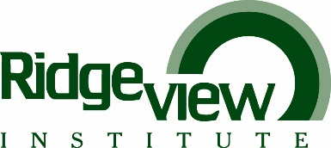

EMPLOYEE ACKNOWLEDGEMENT: DRESS CODE GUIDELINES

I have read, understand and agree to abide by the Ridgeview Institute Smyrna Dress Code guidelines. I also agree to abide by any additional guidelines specific to my individual work area/department.

I understand if my attire is deemed inappropriate, I will be sent home without pay and may receive a disciplinary write-up for my employee file.

_____________________ ____________________________ ________________________
Date Employee Signature Employee’s PRINTED Name

__________________________ ____________________________
Department Head/Supervisor Department Head/Supervisor
Signature Printed Name

Please forward completed acknowledgement to the HUMAN RESOURCES DEPARTMENT.

July 2022

