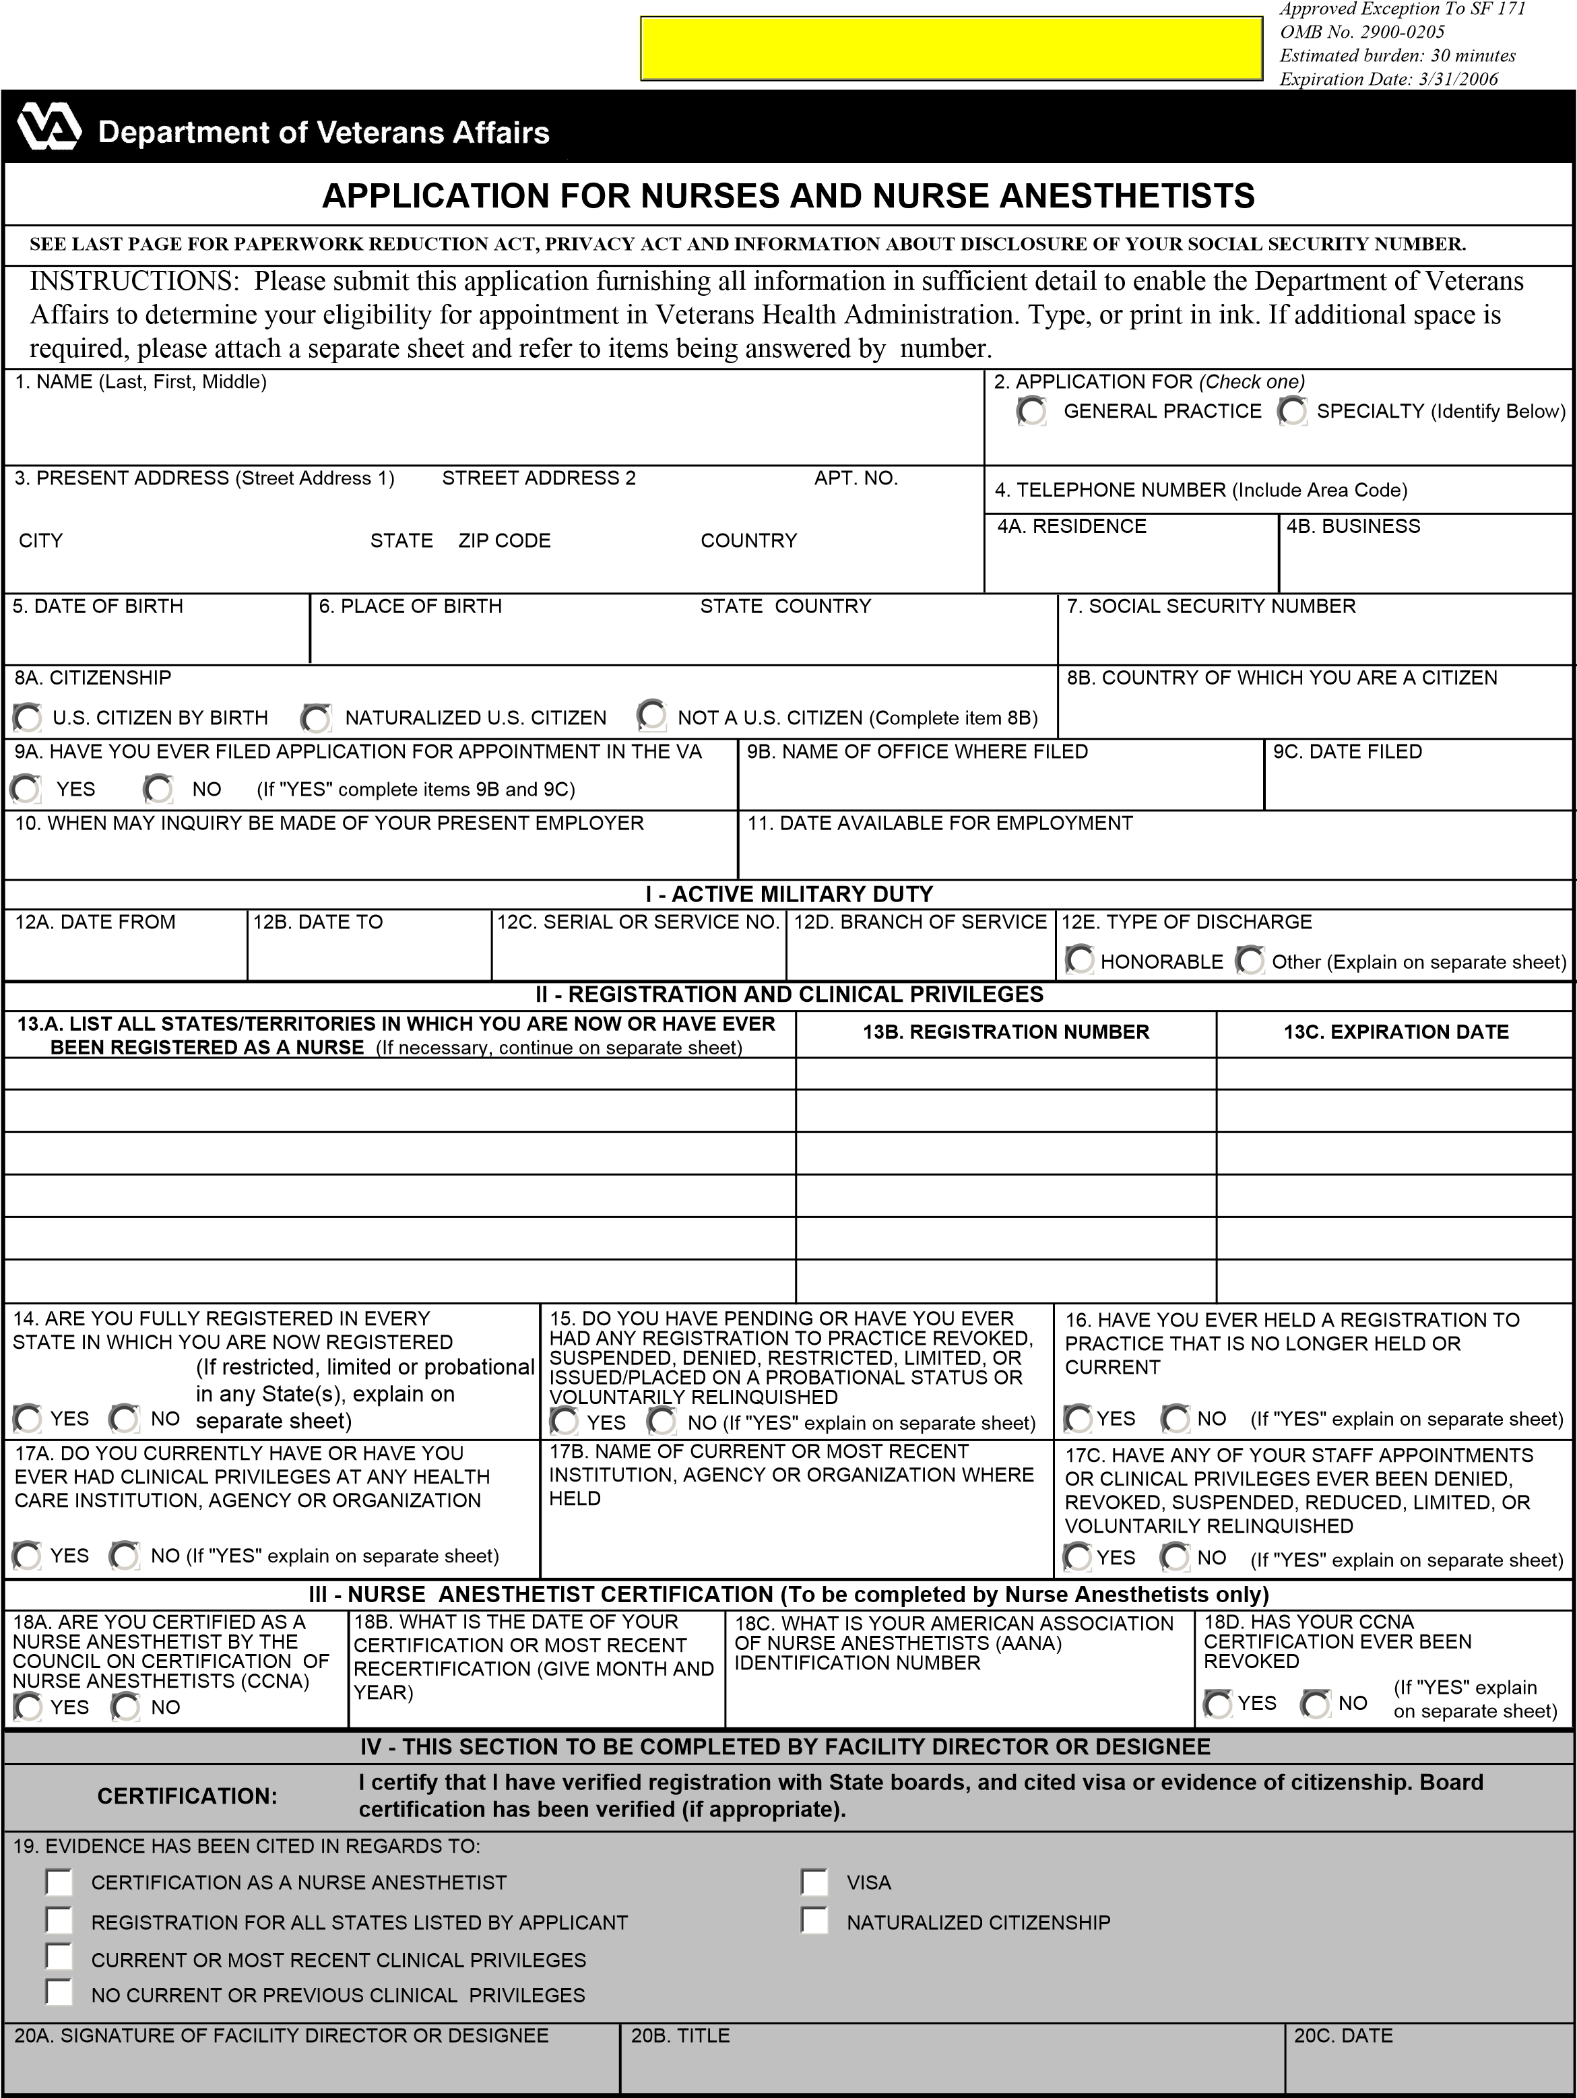
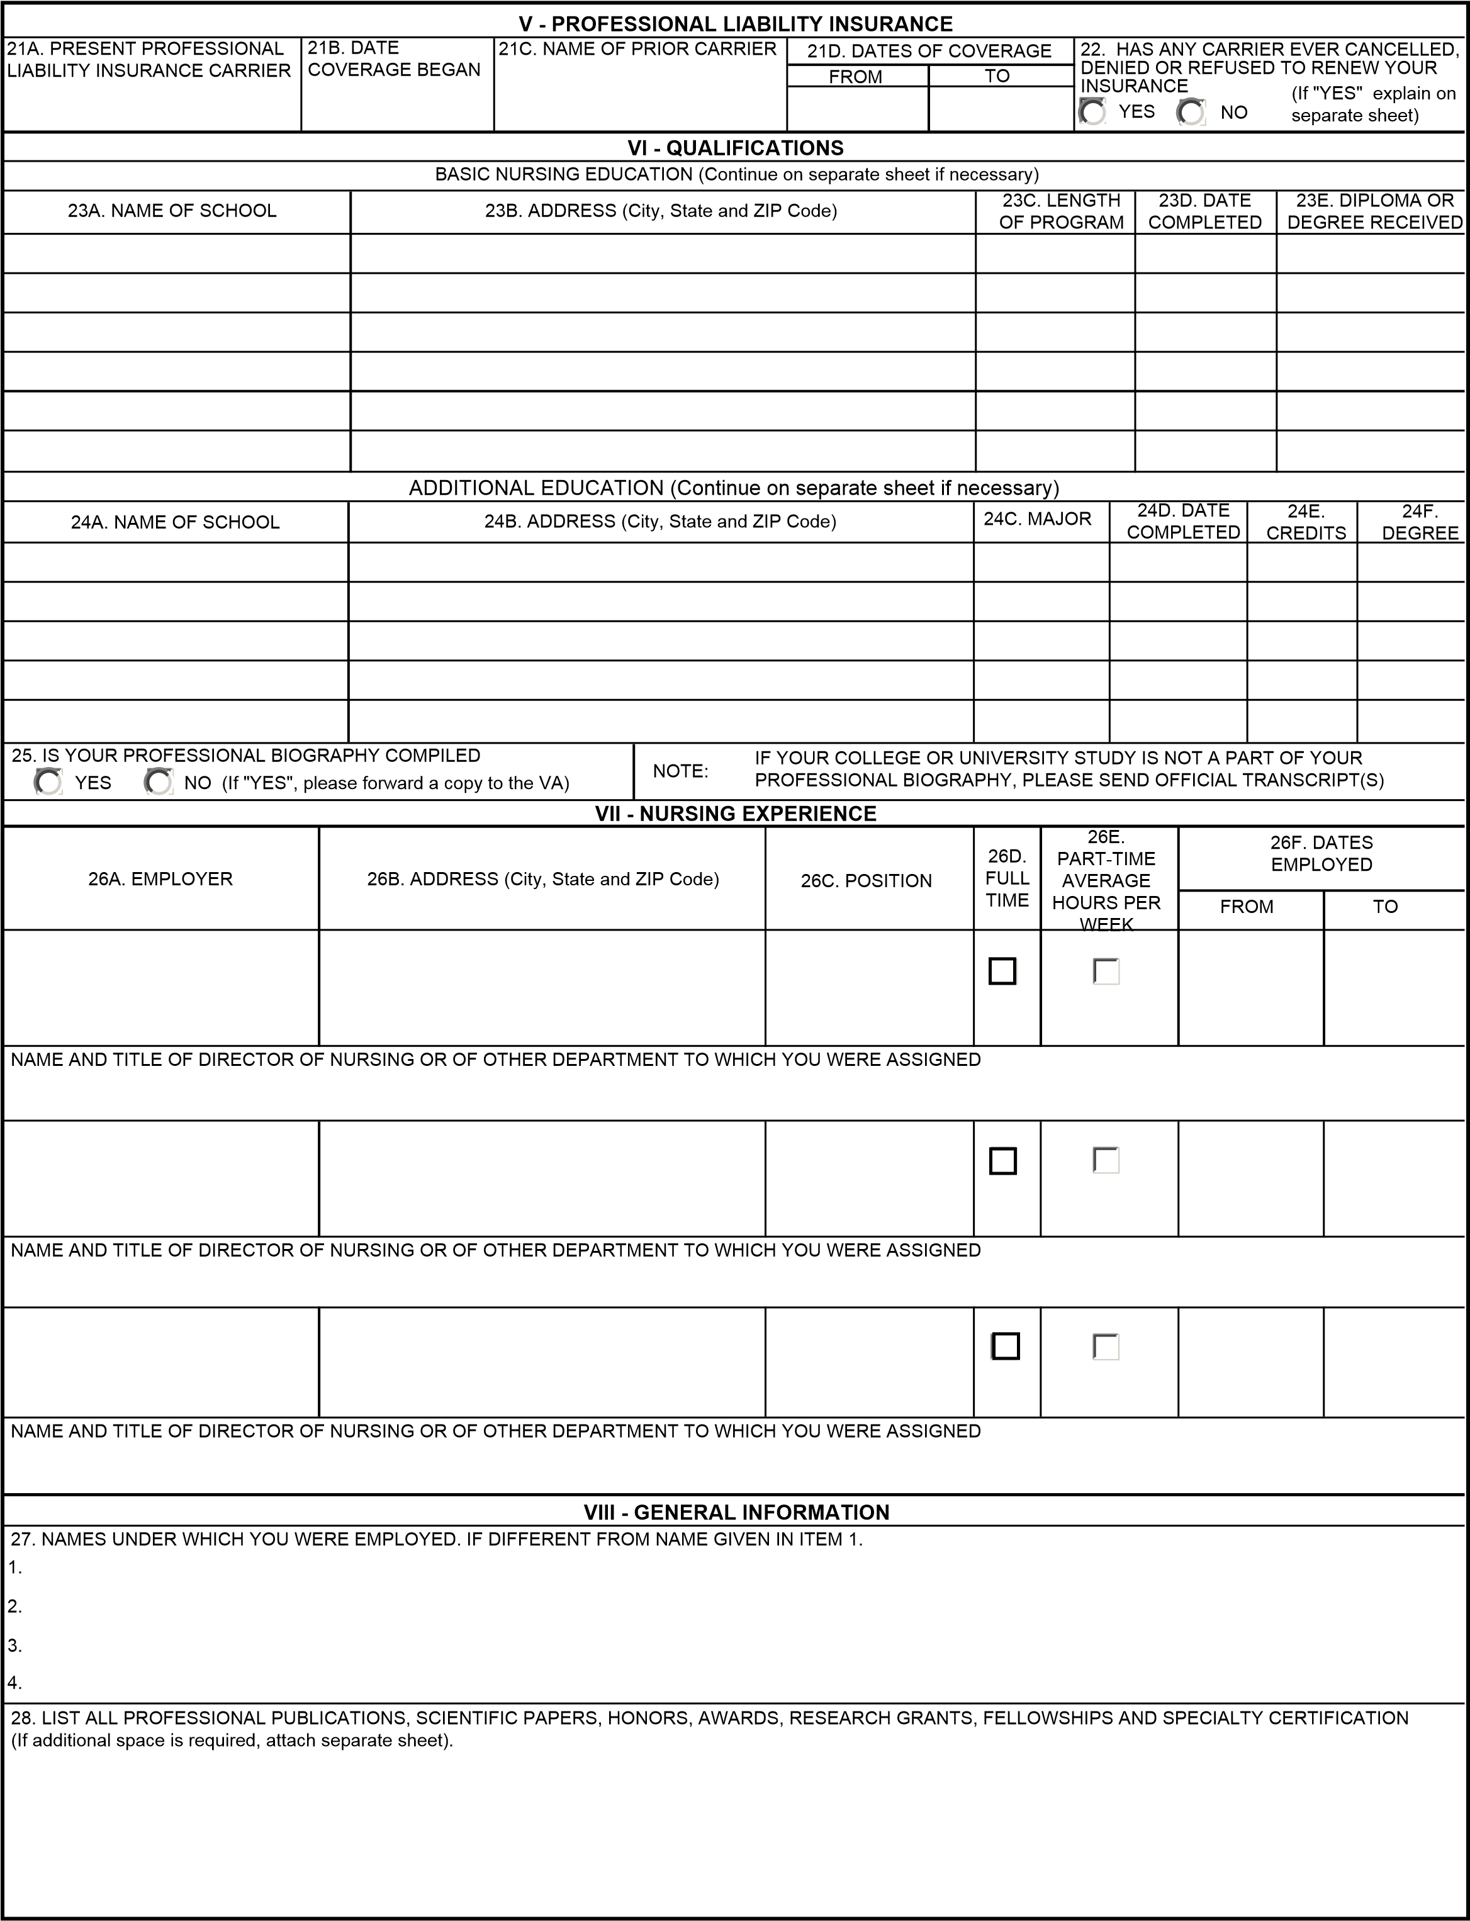

IX - REFERENCES
NOTE: LIST FOUR PERSONS LIVING IN THE UNITED STATES WHO ARE NOT RELATED TO YOU BY BLOOD OR MARRIAGE AND WHO HAVE BEEN IN A POSITION TO JUDGE YOUR PROFESSIONAL QUALIFICATIONS DURING THE PAST FIVE YEARS.
29A. NAME |  | 29B. ADDRESS (Street, City, State and ZIP Code) | 29C. AREA CODE/PHONE NO. | 29D. BUSINESS OR OCCUPATION
ITEM NO. | PLACE AN "X" IN APPROPRIATE SPACE. IF "YES" EXPLAIN DETAILS ON SEPARATE SHEET OF PAPER |  |  |  |  | YES | NO
30. | Do you receive or do you have a pending application for retirement or retainer pay, pension, or other compensation based upon military, Federal civilian, or District of Columbia service?
31. | Does the Department of Veterans Affairs employ any relative of yours (by blood or marriage)? If "YES" give separately such relative's (1) full name; (2) relationship; (3) VA position and employment location.
32. | ARE YOU NOW, OR HAVE YOU EVER BEEN, INVOLVED IN ADMINISTRATIVE, PROFESSIONAL OR  JUDICIAL PROCEEDINGS IN WHICH MALPRACTICE ON YOUR PART IS OR WAS ALLEGED? (If "YES" give details including name of action or proceedings, date filed, court or reviewing agency, and the status or disposition of case concerning allegations, together with your explanation of the circumstances involved.)  (As a provider of health care services, the VA has an obligation to exercise reasonable care in determining that applicants are properly qualified. It is recognized that many allegations of professional malpractice are proven groundless. Any conclusion concerning your answer as it relates to professional qualifications will be made only after a full evaluation of the circumstances involved.)
NOTE: A conviction or a discharge does not necessarily mean you cannot be appointed. The nature of the conviction or discharge and how long ago it occurred is important. Give all the facts so that a decision can be made. If your answer to question 35, 36 or 37 is "YES" give for each offense: (1) date; (2) charge; (3) place; (4) court and (5) action taken. When answering item 35 or 36, you may omit (1) traffic fines for which you paid a fine of $100.00 or less; (2) any offense committed before your 18th birthday which was finally adjudicated in a juvenile court or under a youth offender law; (3) any conviction the record of which has been expunged under Federal or State law; and (4) any conviction set aside under the Federal Youth Corrections Act or similar State authority.
33. | Within the last five years have you been discharged from any position for any reason?
34. | Within the last five years have you resigned or retired from a position after being notified you would be disciplined or discharged, or after questions about your clinical competence were raised?
35. | Have you ever been convicted, forfeited collateral, or are you now under charges for any felony or any firearms or explosives offense against the law? (A felony is defined as any offense punishable by imprisonment for a term exceeding one year, but does not include any offense classified as a misdemeanor under the laws of a State and punishable by a term of imprisonment of two years or less.)
36. | During the past seven years have you been convicted, imprisoned, on probation or parole, or forfeited collateral, or are you now under charges for any offense against the law not included in 35 above?
37. | While in the military service were you ever convicted by a general court-martial?
38. | If you were in the military service in one of these health occupations, did you ever receive a non-judicial punishment (Article 15)?
39. | Are you delinquent on any Federal debt? (Include delinquencies arising from Federal taxes, loans, overpayment of benefits, and other debts to the U.S. Government, plus defaults on any Federally guaranteed or insured loans such as student and home mortgage loans.)  If "Yes" explain on a separate sheet the type, length, and amount of the delinquency or default and steps you are taking to correct errors or repay the debt. Give any identification numbers associated with the debt and the address of the Federal agency involved.
X - SIGNATURE OF APPLICANT
NOTE: A false statement on any part of your application may be grounds for not hiring you, or for terminating you after you begin work. Also, you may be punished by fine or imprisonment (U.S. Code, Title 18, Section 1001).
I CERTIFY THAT TO THE BEST OF MY KNOWLEDGE AND BELIEF, ALL OF MY
^{CERTIFICATION:} STATEMENTS ARE TRUE, CORRECT, COMPLETE, AND MADE IN GOOD FAITH.
40A. SIGNATURE OF APPLICANT |  |  |  |  | 40B. DATE (Month, Day,Year)

AUTHORIZATION FOR RELEASE OF INFORMATION
In order for the Department of Veterans Affairs (VA) to assess and verify my educational background, professional qualifications and suitability for employment, I:
Authorize VA to make inquiries concerning such information about me to my previous employer(s), current employer, educational institutions, State licensing boards, professional liability insurance carriers, national practitioner data bank, American Medical Association, Federation of State Medical Boards, other professional organizations and/or persons, agencies, organizations or institutions listed by me as references, and to any other appropriate sources to whom VA may be referred by those contacted or deemed appropriate; Authorize release of such information and copies of related records and/or documents to VA officials;
Release from liability all those who provide information to VA in good faith and without malice in response to such inquiries; and
Authorize VA to disclose to such persons, employers, institutions, boards or agencies identifying and other information about me to enable VA to make such inquiries.
SIGNATURE OF APPLICANT | DATE
PAPERWORK REDUCTION ACT AND PRIVACY ACT NOTICE
The Paperwork Reduction Act of 1995 requires us to notify you that this information collection is in accordance with the clearance requirements of section 3507 of the Paperwork Reduction Act of 1995. We may not conduct or sponsor, and you are not required to respond to, a collection of information unless it displays a valid OMB number. We anticipate that the time expended by all individuals who must complete this form will average 30 minutes. This includes the time it will take to read instructions, gather the necessary facts and fill out the form.
AUTHORITY: The information requested on the attached application form and Authorization for Release of Information is solicited under Title 38, United States Code, Chapters 73 and 74.
PURPOSES AND USES: The information requested on the application is collected primarily to determine your qualifications and suitability for employment. If you are employed by the VA, the information will be used to make pay and benefit determinations and, as necessary, in personnel administration processes carried out in accordance with established regulations and published notices of systems of records.
ROUTINE USES: Information on the form or the form itself may be released without your prior consent outside the VA to another Federal, State or local agency, to the National Practitioner Data Bank which is administered by the Department of Health and Human Services, to State licensing boards, and/or appropriate professional organizations or agencies to assist the VA in determining your suitability for hiring and for employment, to periodically verify, evaluate and update your clinical privileges and licensure status, to report apparent or potential violations of law, to provide statistical data upon proper request, or to provide information to a Congressional office in response to an inquiry made at your request. Such information may also be released without your prior consent to Federal agencies, State licensing boards, or similar boards or entities, in connection with the VA's reporting of information concerning your separation or resignation as a professional staff member under circumstances which raise serious concerns about your professional competence. Information concerning payments related to malpractice claims and adverse actions which affect clinical privileges also may be released to State licensing boards and the National Practitioner Data Bank. The information you supply may be verified through a computer matching program at any time.
EFFECTS OF NON-DISCLOSURE: See statement below concerning disclosure of your social security number. Disclosure of the other information is voluntary; however, failure to provide this information may delay or make impossible the proper application of Civil Service rules and regulations and VA personnel policies and thus may prevent you from obtaining employment, employees benefits, or other entitlements.
INFORMATION REGARDING DISCLOSURE OF YOUR SOCIAL SECURITY NUMBER UNDER PUBLIC LAW 93-579 SECTION 7(b)
Disclosure of your SSN (social security number) is mandatory to obtain the employment and related benefits that you are seeking. Solicitation of the SSN is authorized under the provisions of Executive Order 9397, dated November 22, 1943. The SSN is used as an identifier throughout your Federal career from the time of application through retirement. It will be used primarily to identify your records. The SSN also will be used by Federal agencies in connection with lawful requests for information about you from your former employers, educational institutions, and financial or other organizations. The information gathered through the use of the number will be used only as necessary in personnel administration processes carried out in accordance with established regulations and published notices of systems of records. The SSN also will be used for the selection of persons to be included in statistical studies of personnel management matters. The use of the SSN is made necessary because of the large number of present and former Federal employees and applicants who have identical names and birth dates, and whose identities can only be distinguished by the SSN.
PAGE 4

