Instructions for creating a Travel Request in Concur

Prior to going into Concur you will need to use Google Maps to find out the roundtrip mileage to your clinical site(s). Multiply that mileage by the approximate number of times you will be visiting the site for that month. Take that total number of miles and multiply by $.55 to get the approximate amount of money you will be reimbursed at the end of the month.
1. Login into Concur
2. Click on the Request tab and then New Request
3. Complete the fields on the screen
- Request Name: month (i.e. June, or July) 2017 Clinical visits
- Trip Type: use drop down menu to select Domestic
- Request Policy: do not change from KSU Request Policy
- Start Date: enter your first day of travel for this request
- End Date: enter your last day of travel for this request
- Purpose: Supervise Students
- SpeedChart: It should read HHS-Nursing (07052), if it does not, call me
- Comment: (explain why and where you are going) i.e. Supervise Students in NURS
3313 at Kennestone Hospital
- Click on the Save button on the right side of the screen.

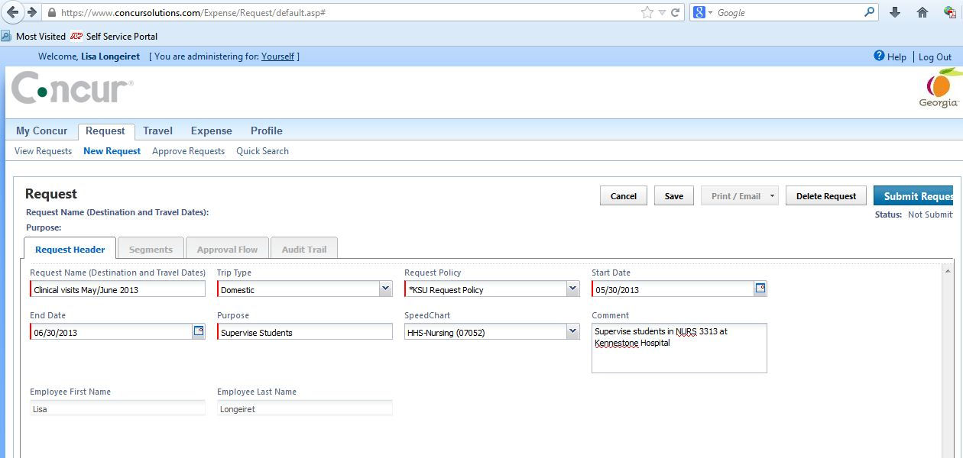

4. Click on the Segments tab and then on the Blue circle with a magnifying glass picture (Miscellaneous)
- Amount: Fill in the amount that you have already calculated
- Comment: Fill in the Comment section with something like: Personal car mileage from home to site 3 times during the month.
- Click on the Save button at the bottom of the screen
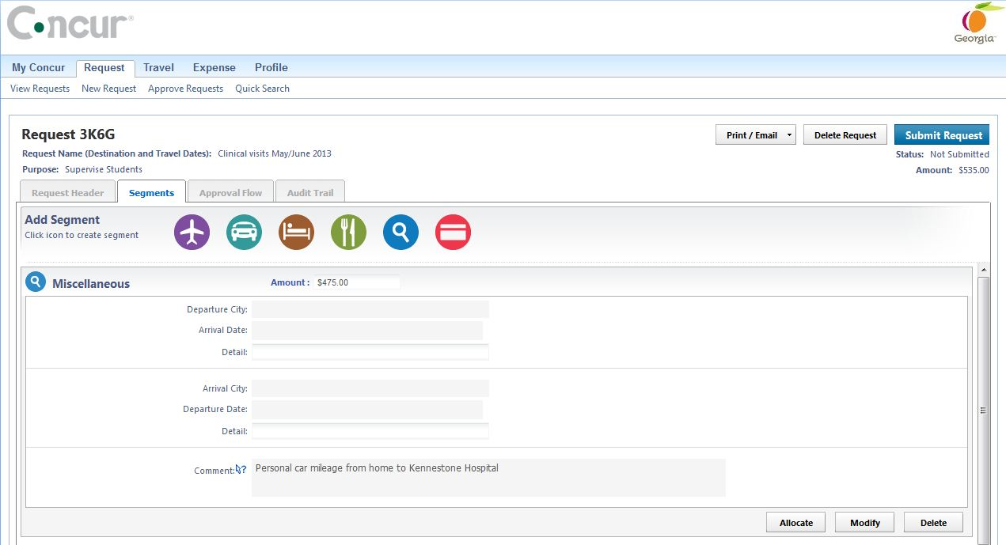

5. If you expect to pay for parking then click on the Blue circle again.
- Amount: Fill in the amount that think it will cost you to park
- Comment: Fill in the Comment section with: i.e., Parking at Kennestone Hospital 10 times.
- Click on the Save button at the bottom of the screen
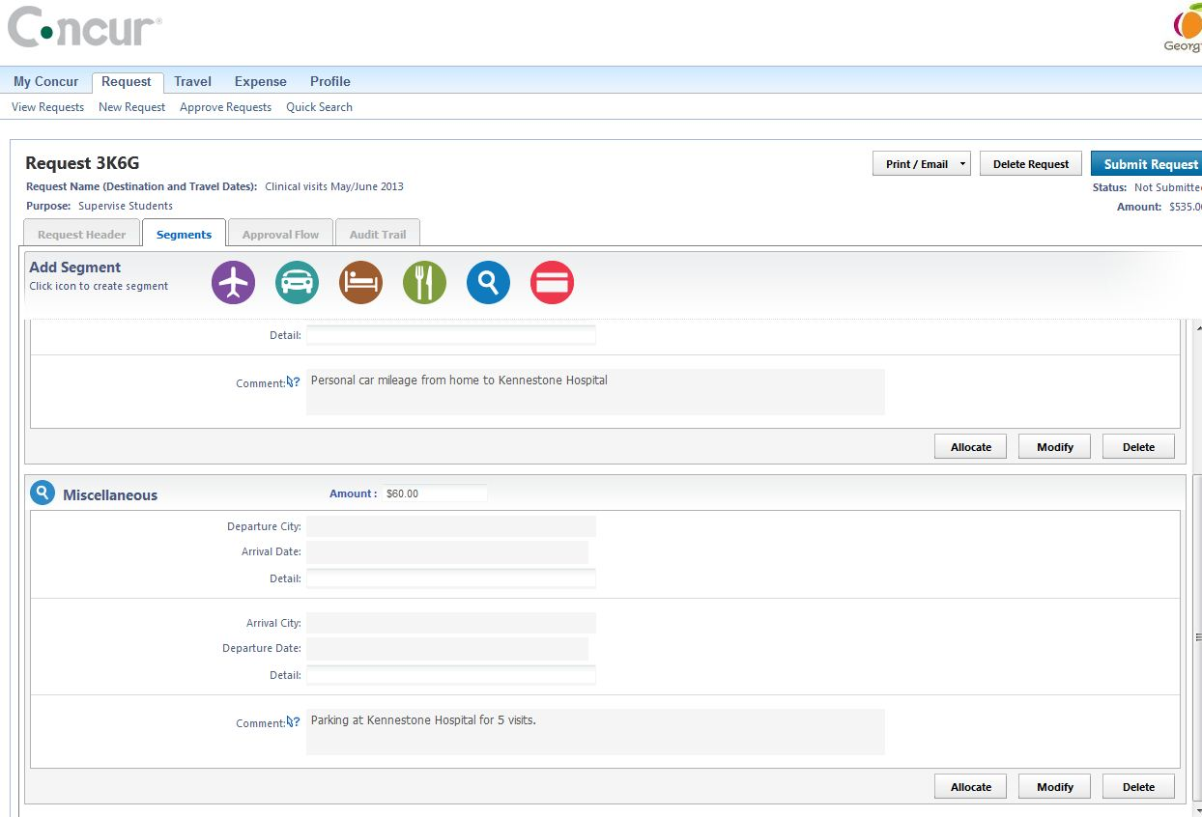
6. Print a copy of your request and log out.
7. Send me an email to let me know that you have completed the Travel Request. I will review it for you and let you know when you can submit it.

PLEASE DO NOT CLICK THE SUBMIT BUTTON UNTIL I ASK YOU TO DO SO.

