Creating an Expense Report for Clinical Travel in Concur

The following instructions are for creating an expense report for your clinical travel. All expense reports must be paid within 60 days of your first day of travel therefore you are required to submit an expense report for each month.

- Log onto Concur: https://www.concursolutions.com
- Once you have logged into Concur on the home page click on the Request link
- If no requests are in the queue click on the (blue) View drop down menu and click on approved requests. Select the request for this month and open it. (If you did not create a travel request click on the Expense button in the black bar at the top of the screen.)
- Click on the Create Expense Report button in the top middle of the screen.

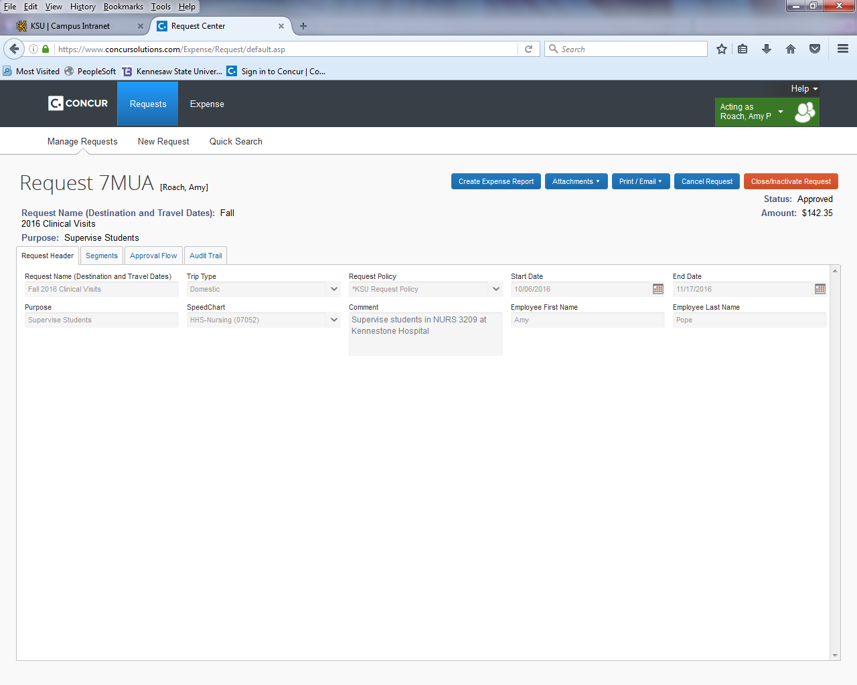

- The following screen will appear: Report Header
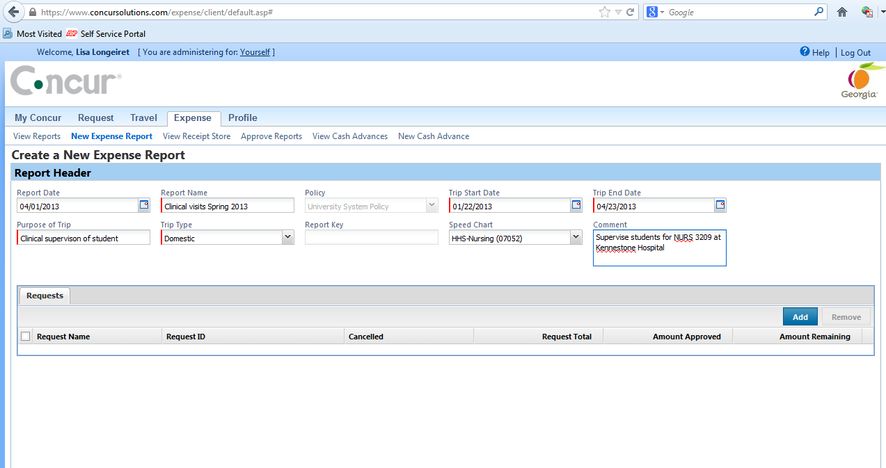
Report Name: enter “ Month (i.e., January) 2018 Clinical visits”
Trip Start date: Date of 1st clinical visit for this report
Trip End Date: Date of last clinical visit for this report
Purpose of trip: “Clinical supervision of students”
Trip Type: Click on arrow and select Domestic
Comment Box: “Supervise students for NURS (3209 or 3313 or 4412 whichever course you taught) at (list all the sites that you visited during the semester for KSU).
- Click the Next button on the bottom of the screen
- A box will appear with the question: “Will this report include food expenses?” Click No

- The following page will appear: on the right side click on Personal Car Mileage

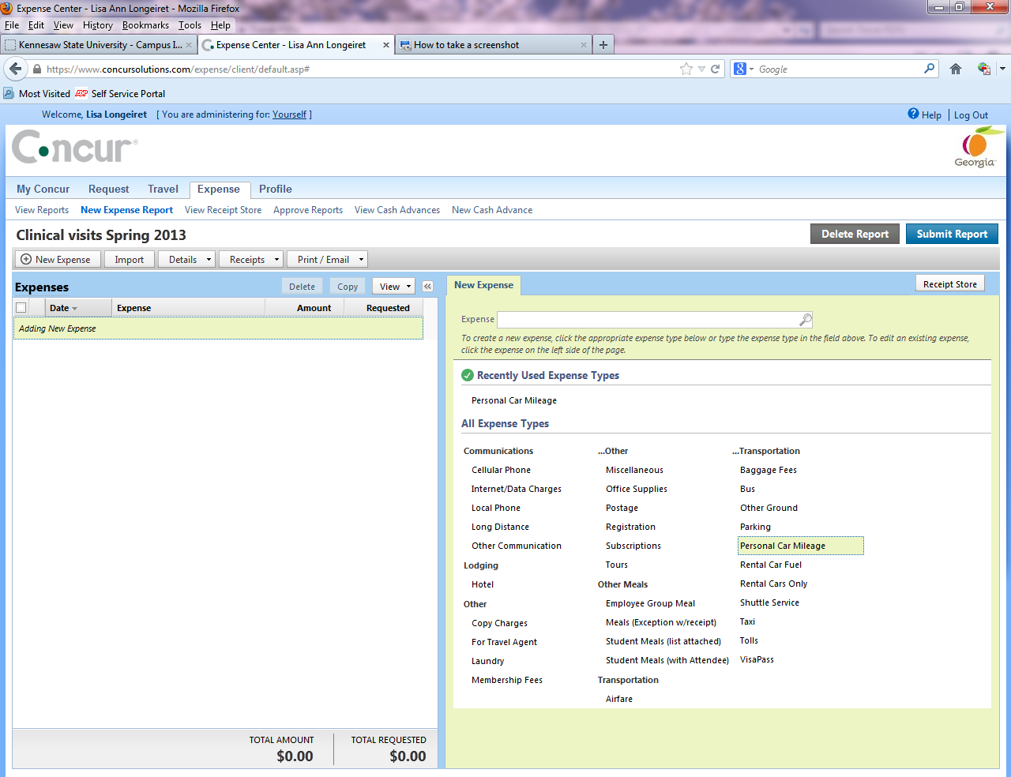

Transaction Date: the date that you traveled to a clinical site (you will create a new entry for each date you did a clinical visit)
Traveler Type: click on the arrow and select Employee
Leave the location blocks blank
Click on Mileage Calculator (see next page for screen shot). This will take you to Google Maps
Create your trip and don’t forget to click on Make Roundtrip. (If you don’t know how to do this call me)
For Faculty with on campus offices you will need click on the deduct commuter miles button and the deduct roundtrip commute if you left from home and returned home. If you left from or returned to campus then you need to change the address.
Click on Add Mileage to Expense button (bottom right)
Click Save on the next page that appears and your trip will be listed on the left side of the page (see following screen shot).
Repeat these steps in #6 until you have added all of your trips and they are listed on the left side of the screen under expenses.
(If you do the same trip multiple times, call Lisa & she’ll walk you through a short cut)

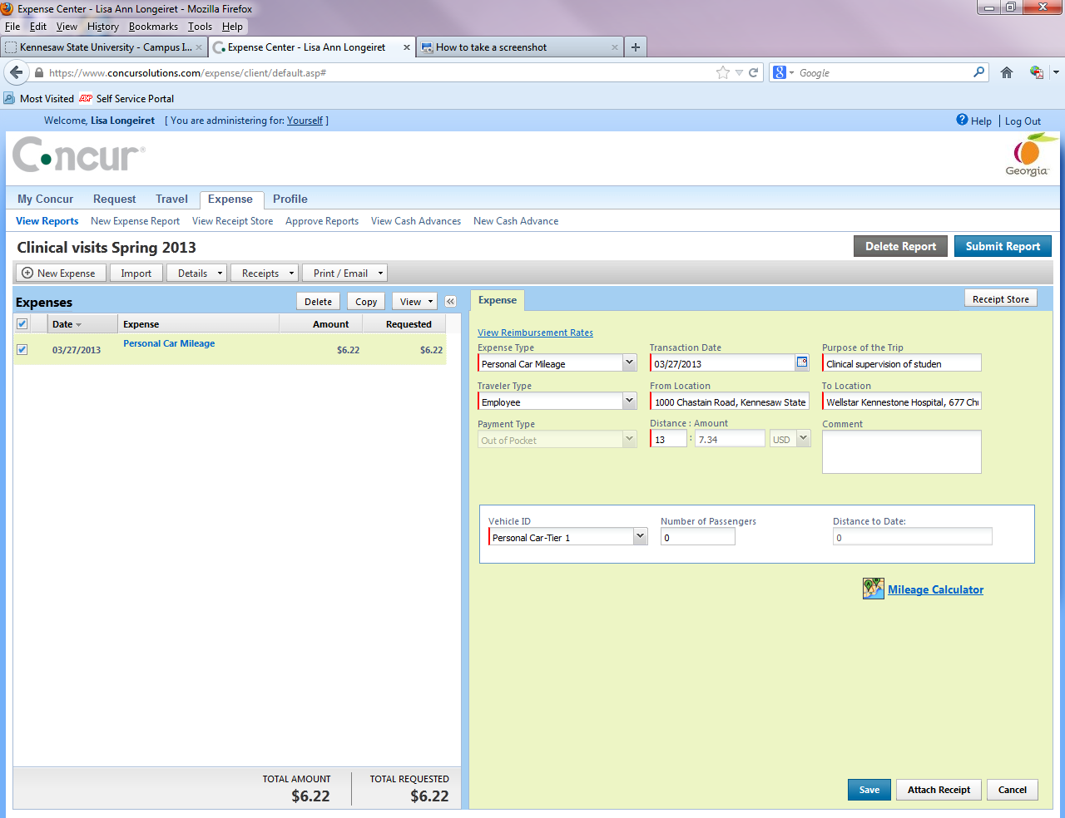
- If you have parking receipts – you will need to click on parking link and fill in a separate entry for each receipt and you will have to scan and upload your receipts in a PDF format. If you do not have a scanner that can do that, please bring or send me your receipts so that I can do it for you.
- Once you have entered all your clinical visits and receipts into Concur please email or call Lisa.

Call Lisa Longeiret with any questions regarding this process. She can walk you through it over the phone (470-578-6093).

PLEASE DO NOT SUBMIT YOUR EXPENSE REPORT UNTIL LISA HAS SENT YOU AN EMAIL REQUESTING YOU TO DO SO.

